Mini Thermal Cycler—MTC3200
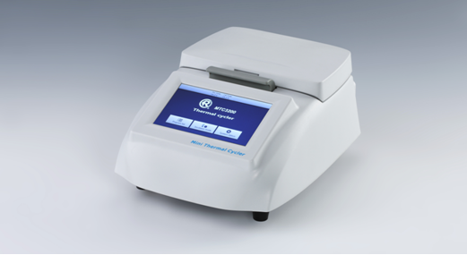

1. Introduction
Mini Thermal Cycler is a compact, accurate and economical thermal cycler, designed to fit lab’s basic thermal cycling needs. The operation of the thermal cycler is controlled by a 5-inch color touch screen. It has a capacity for 32x0.2ml tubes. The wells are arranged in a 4x8 format, allowing the block to accept strips of 8 as well as individual tubes. Excellent block uniformity ensures consistency sample to sample. Fast incubation function meets the experimental needs of denaturation, enzyme digestion / enzyme linkage, ELISA, etc. With a small footprint, the Mini Thermal Cycler will fit almost anywhere.

Features:
- Capacity: 32x0.2ml tubes and 4x8 tube strips
- Heating/cooling method: Peltier
- 5-inch intuitive color touch screen—for easy programming of users.
- 100 typical programs can be stored in memory and easily recalled.
- The block heats and cools very quickly—at rates as fast as 4°C/sec.
- The heated lid is self adjusting—the spring loaded platen in the lid comes firmly into contact with the tops of the tubes to prevent sample evaporation and condensation.
- Temperature of heated lid can be changed or the heating function of the lid can be turned off.
- After a run, samples can be held at 4°C.
- An on-screen report is available at the completion of a run.

2. Parameters
Model | MTC3200
Capacity | 32x0.2ml tubes, 4x8 tube strips
Temp. setting range | 0℃~100℃
Temp. control range | 4℃~100℃
Temp. accuracy/uniformity | ≤±0.25℃/≤±0.25℃
Max. heating rate | 4℃/sec
Max. cooling rate | 2℃/sec
Heated lid temperature | RT.+5℃~110℃, user adjustable
Temp. display resolution | 0.1℃
Temp. control | Simulated sample or block
Display | 5-inch color touch screen, 800x480 Pixel
Communication interface | USB(1 port)
Program memory | 100 programs
Time increments/decrements | 1~120s
Temp. increments/decrements | 0.1~9.9℃
Storage at 4℃ | Yes
On-screen report | Yes
Power | 200W
Voltage | AC100~240V, 50-60Hz
Fuse | 250V 3A Ф5×20
Dimension(mm) | 264x200x125
Weight(kg) | 2.3

